[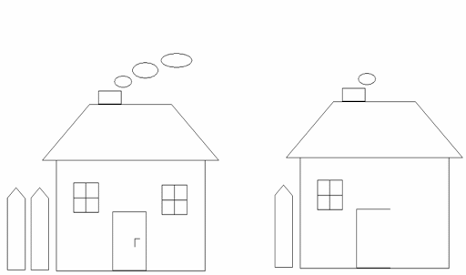](https://www.google.pl/url?sa=i&url=http%3A%2F%2Fsp3lubartow.internetdsl.pl%2FPublikacje%2FZmienne%2FInne.htm&psig=AOvVaw1aYaMuwdymjb92EsBLHFmz&ust=1585413409136000&source=images&cd=vfe&ved=0CAIQjRxqFwoTCLCWsKuLu-gCFQAAAAAdAAAAABAO)

[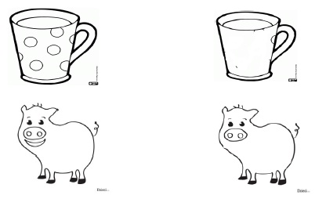](https://www.google.pl/url?sa=i&url=http%3A%2F%2Fwww.labiryntslow.com.pl%2Fciekawostki.html&psig=AOvVaw1aYaMuwdymjb92EsBLHFmz&ust=1585413409136000&source=images&cd=vfe&ved=0CAIQjRxqFwoTCLCWsKuLu-gCFQAAAAAdAAAAABAu)

[](https://www.google.pl/url?sa=i&url=https%3A%2F%2Feduzabawy.com%2Fmaterialy-tematyczne-do-druku%2Fhalloween%2Fdorysuj-brakujace-elementy2%2F&psig=AOvVaw1aYaMuwdymjb92EsBLHFmz&ust=1585413409136000&source=images&cd=vfe&ved=0CAIQjRxqFwoTCLCWsKuLu-gCFQAAAAAdAAAAABA0)

[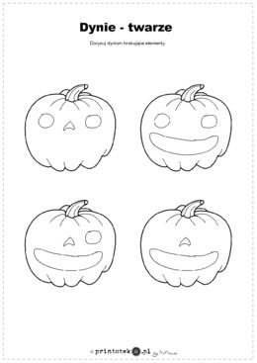](https://www.google.pl/url?sa=i&url=https%3A%2F%2Fwww.printoteka.pl%2Fql%2Fmaterials%2Fitem%2F571&psig=AOvVaw1aYaMuwdymjb92EsBLHFmz&ust=1585413409136000&source=images&cd=vfe&ved=0CAIQjRxqFwoTCLCWsKuLu-gCFQAAAAAdAAAAABBM)

[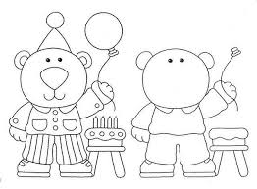](https://www.google.pl/url?sa=i&url=https%3A%2F%2Fmp75kat.szkolnastrona.pl%2Findex.php%3Fc%3Dgetfile%26id%3D152&psig=AOvVaw1aYaMuwdymjb92EsBLHFmz&ust=1585413409136000&source=images&cd=vfe&ved=0CAIQjRxqFwoTCLCWsKuLu-gCFQAAAAAdAAAAABBR)

[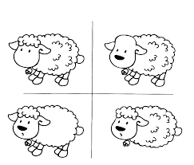](https://www.google.pl/url?sa=i&url=http%3A%2F%2Fimg.iap.pl%2Fs%2F123%2F207054%2FEdytor%2FFile%2FGazetka_przedszkolna.pdf&psig=AOvVaw1aYaMuwdymjb92EsBLHFmz&ust=1585413409136000&source=images&cd=vfe&ved=0CAIQjRxqFwoTCLCWsKuLu-gCFQAAAAAdAAAAABBW)

[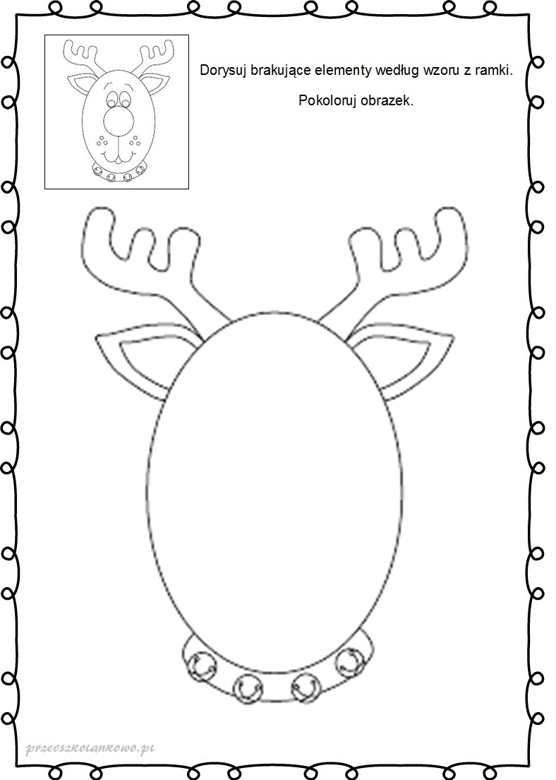](https://www.google.pl/url?sa=i&url=https%3A%2F%2Fprzedszkolankowo.pl%2F2016%2F12%2F05%2Freniferowe-karty-pracy-zestaw-1%2Fr7%2F&psig=AOvVaw1aYaMuwdymjb92EsBLHFmz&ust=1585413409136000&source=images&cd=vfe&ved=0CAIQjRxqFwoTCLCWsKuLu-gCFQAAAAAdAAAAABBa)