[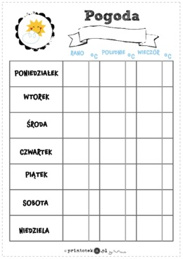](https://www.google.pl/url?sa=i&url=https%3A%2F%2Fwww.printoteka.pl%2Fml%2Fmaterials%2Fitem%2F827&psig=AOvVaw1SKBofFrBPV2R-Bp3WINTh&ust=1584437838993000&source=images&cd=vfe&ved=0CAIQjRxqFwoTCOjch4nZnugCFQAAAAAdAAAAABAN)