[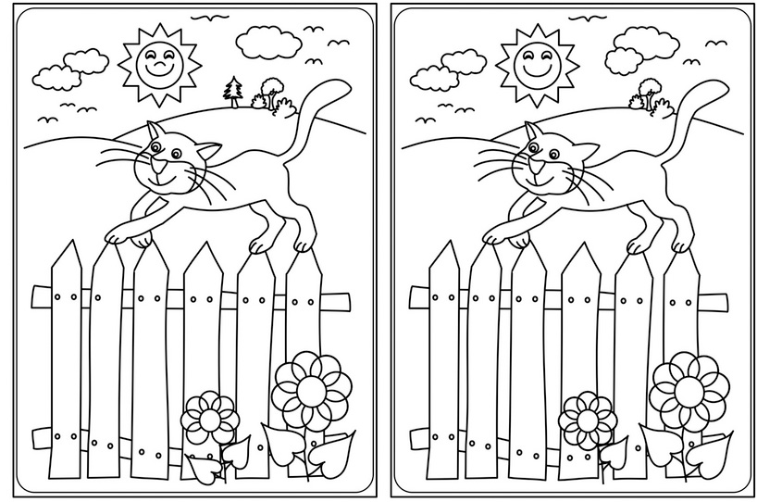](https://www.google.pl/url?sa=i&url=http%3A%2F%2Fwww.malyprzewodnik.pl%2FGry-i-zabawy%2FZadania-katechetyczne%2FZnajdz-roznice&psig=AOvVaw2dapBL5TskK8dl0pv4m6O6&ust=1585412744864000&source=images&cd=vfe&ved=0CAIQjRxqFwoTCND-tPCIu-gCFQAAAAAdAAAAABAD)

[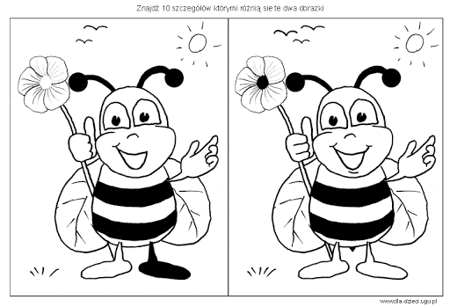](https://www.google.pl/url?sa=i&url=http%3A%2F%2Fwww.dla-dzieci.ugu.pl%2Fznajdz-roznice-zabawy-dla-dzieci%2F&psig=AOvVaw2dapBL5TskK8dl0pv4m6O6&ust=1585412744864000&source=images&cd=vfe&ved=0CAIQjRxqFwoTCND-tPCIu-gCFQAAAAAdAAAAABAP)

[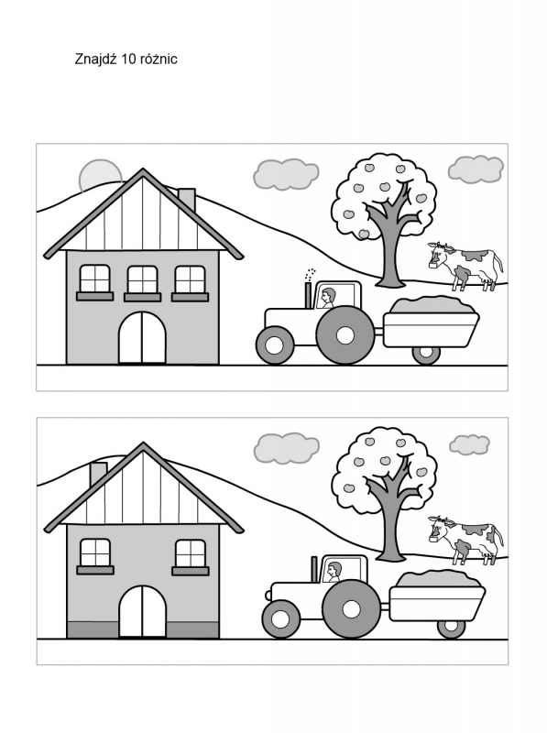](https://www.google.pl/url?sa=i&url=https%3A%2F%2Fwww.szkolneblogi.pl%2Fblogi%2Fsko-brzesko%2Fznajdz-roznice%2F&psig=AOvVaw2dapBL5TskK8dl0pv4m6O6&ust=1585412744864000&source=images&cd=vfe&ved=0CAIQjRxqFwoTCND-tPCIu-gCFQAAAAAdAAAAABAu)

[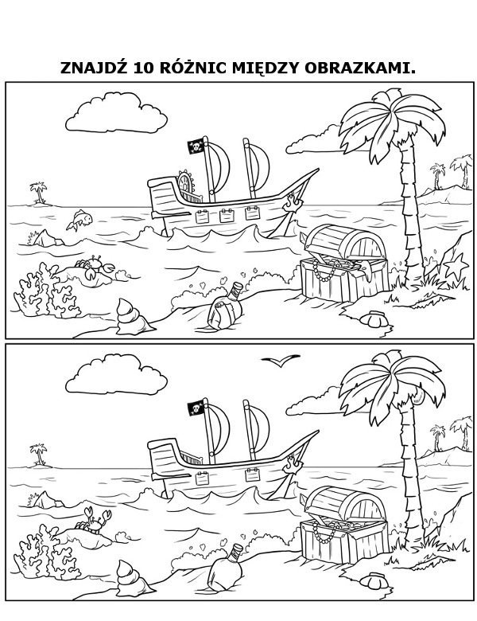](https://www.google.pl/url?sa=i&url=https%3A%2F%2Fwww.e-kolorowanki.eu%2Fkolorowanki-edukacyjne%2Froznice%2Fznajdz-roznice-kolorowanka-5%2F&psig=AOvVaw2dapBL5TskK8dl0pv4m6O6&ust=1585412744864000&source=images&cd=vfe&ved=0CAIQjRxqFwoTCND-tPCIu-gCFQAAAAAdAAAAABAz)

[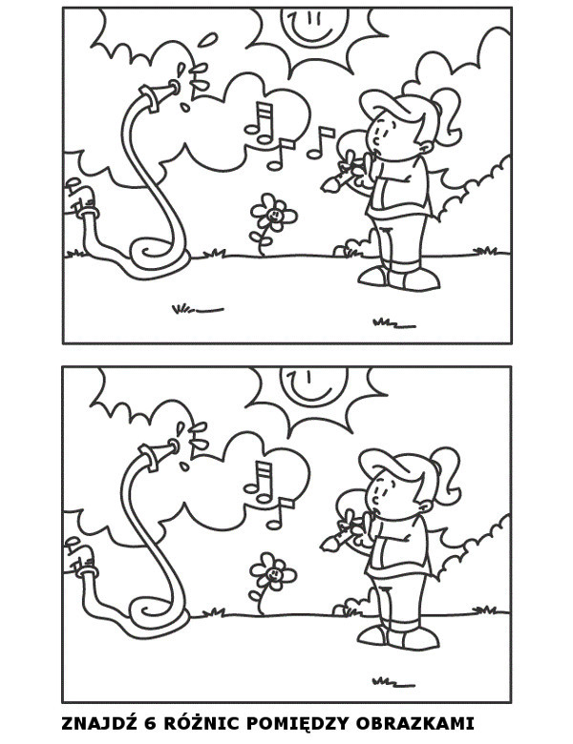](https://www.google.pl/url?sa=i&url=https%3A%2F%2Fwww.e-kolorowanki.eu%2Fkolorowanki-edukacyjne%2Froznice%2Fznajdz-roznice-kolorowanka-19%2F&psig=AOvVaw2dapBL5TskK8dl0pv4m6O6&ust=1585412744864000&source=images&cd=vfe&ved=0CAIQjRxqFwoTCND-tPCIu-gCFQAAAAAdAAAAABA9)

[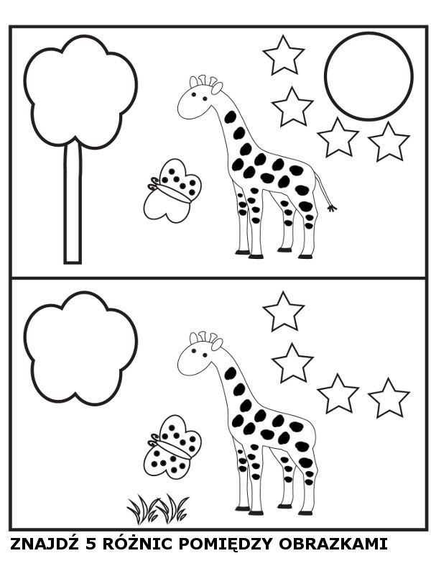](https://www.google.pl/url?sa=i&url=https%3A%2F%2Fwww.e-kolorowanki.eu%2Fkolorowanki-edukacyjne%2Froznice%2Fznajdz-roznice-kolorowanka-27%2F&psig=AOvVaw2dapBL5TskK8dl0pv4m6O6&ust=1585412744864000&source=images&cd=vfe&ved=0CAIQjRxqFwoTCND-tPCIu-gCFQAAAAAdAAAAABBC)[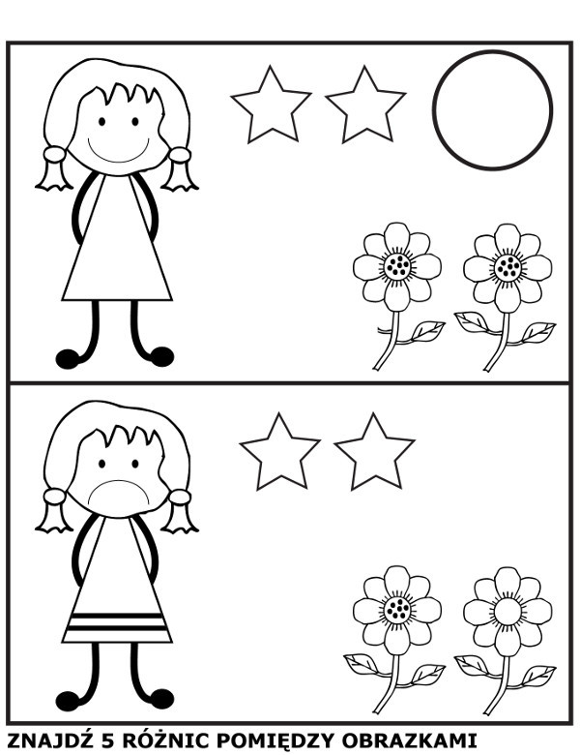](https://www.google.pl/url?sa=i&url=https%3A%2F%2Fwww.e-kolorowanki.eu%2Fkolorowanki-edukacyjne%2Froznice%2Fznajdz-roznice-kolorowanka-26%2F&psig=AOvVaw2dapBL5TskK8dl0pv4m6O6&ust=1585412744864000&source=images&cd=vfe&ved=0CAIQjRxqFwoTCND-tPCIu-gCFQAAAAAdAAAAABBH)

[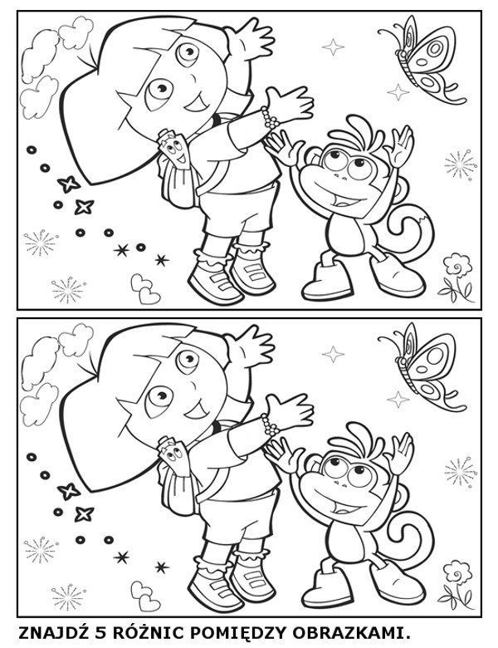](https://www.google.pl/url?sa=i&url=https%3A%2F%2Fwww.e-kolorowanki.eu%2Fkolorowanki-edukacyjne%2Froznice%2Fznajdz-roznice-kolorowanka-10%2F&psig=AOvVaw2dapBL5TskK8dl0pv4m6O6&ust=1585412744864000&source=images&cd=vfe&ved=0CAIQjRxqFwoTCND-tPCIu-gCFQAAAAAdAAAAABBL)[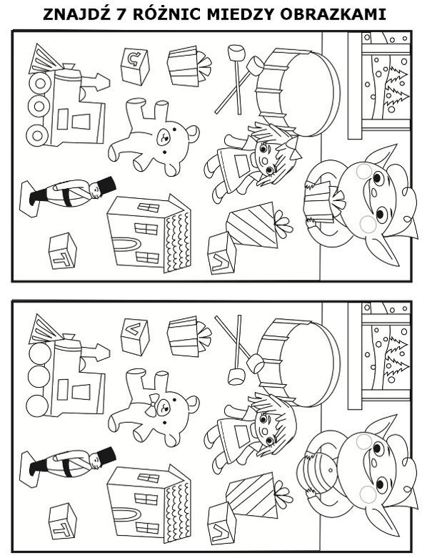](https://www.google.pl/url?sa=i&url=https%3A%2F%2Fwww.e-kolorowanki.eu%2Fkolorowanki-edukacyjne%2Froznice%2Fznajdz-roznice-kolorowanka-9%2F&psig=AOvVaw2dapBL5TskK8dl0pv4m6O6&ust=1585412744864000&source=images&cd=vfe&ved=0CAIQjRxqFwoTCND-tPCIu-gCFQAAAAAdAAAAABBQ)